# Digital Verification using SV and UVM

# Assignment-4

# Name: Fares Khalaf Sultan

# Q1) ) ALSU

# Package class:

# 

# 

# 

# TestBench:

# 

# 

# 

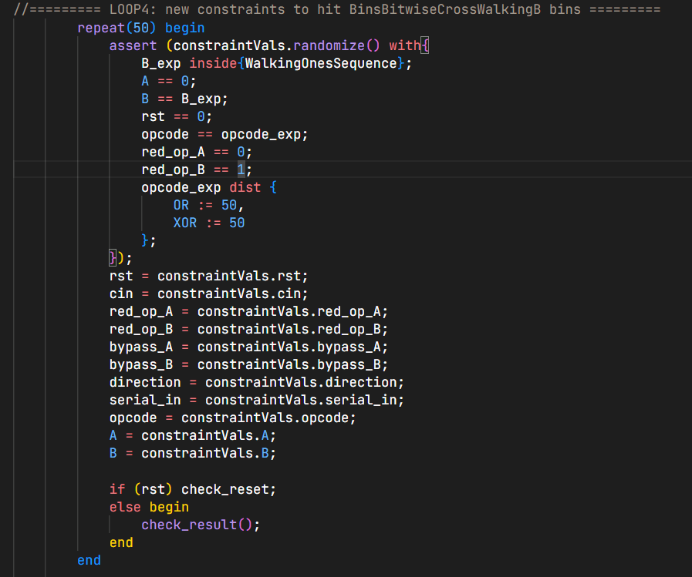

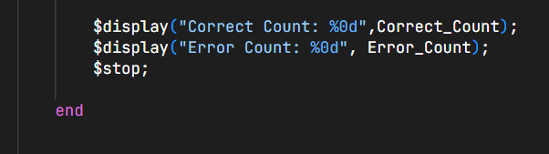

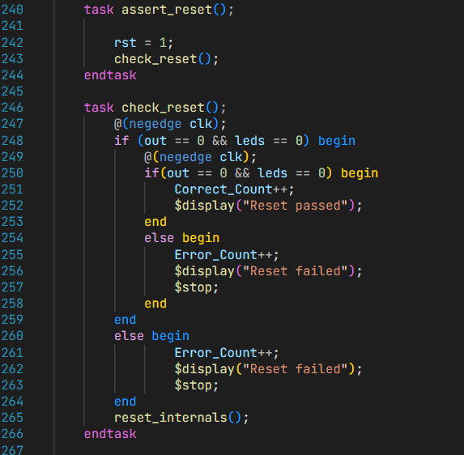

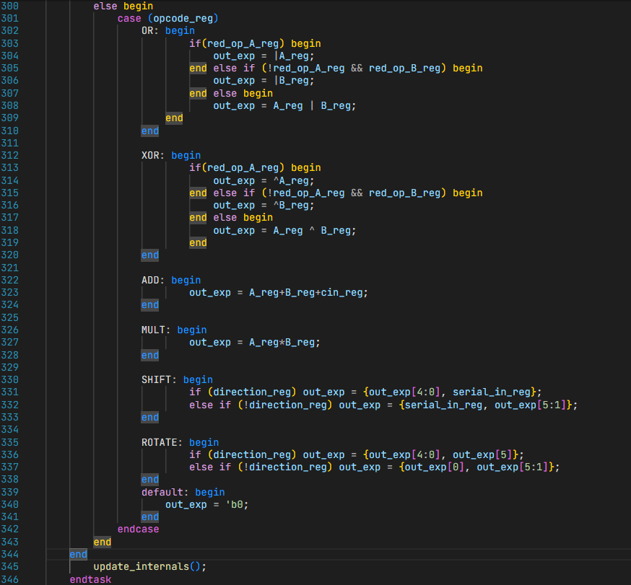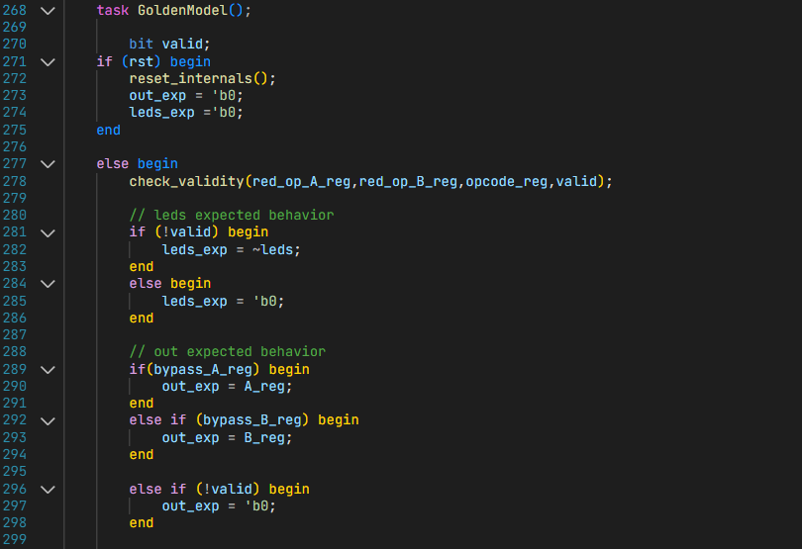

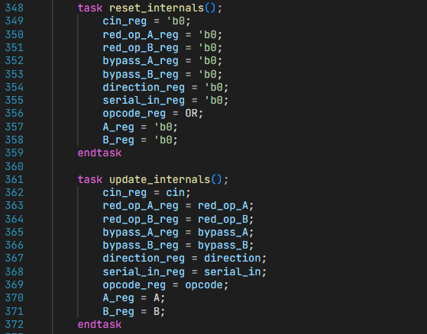

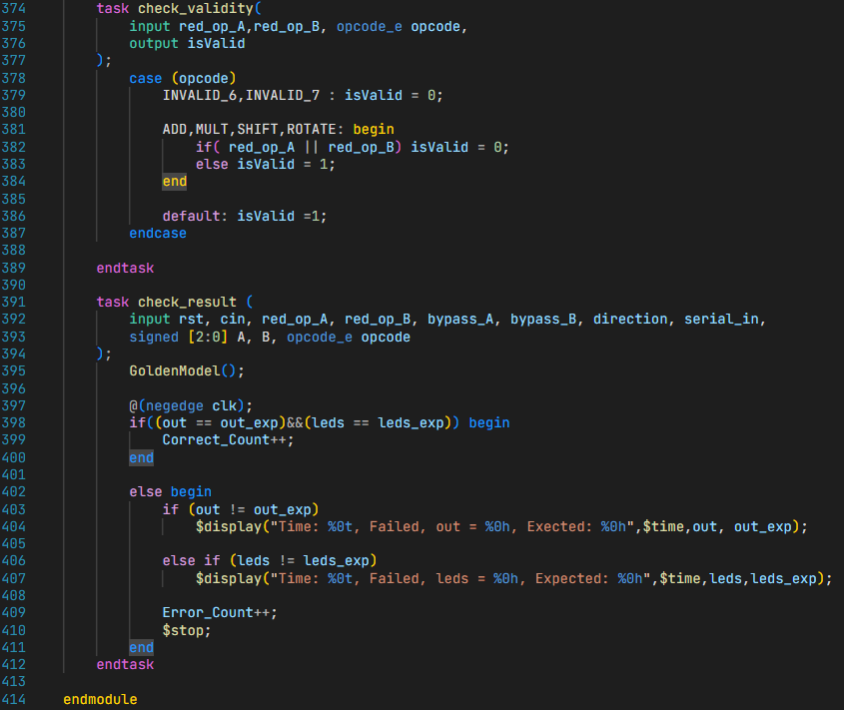

# 

# Do file:

# 

# Results:

# 

# Waveform:

# Functional Coverage Report:

# 

# Coverage Report:

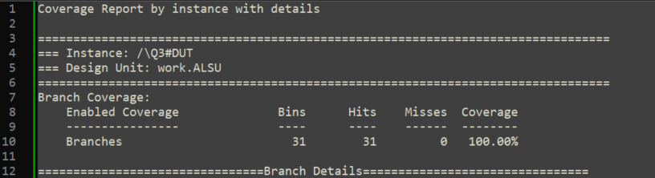

* Excluded **all False case** in the case statement, since invalid opcodes are handled by the flag (**invalid_opcode**)

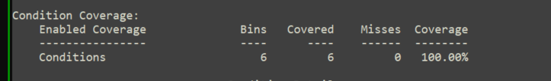

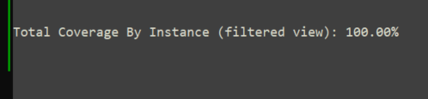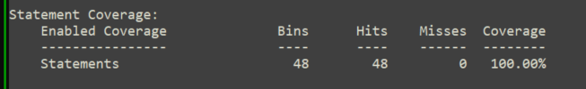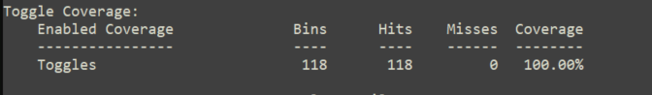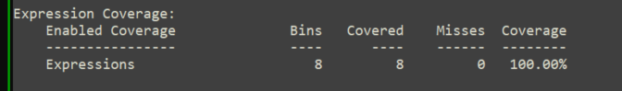

# Q2) Write Assertions:

# 

# Q3) Counter:

# Verification Plan:

|  |  |  |  |  |
| --- | --- | --- | --- | --- |
| **Label** | **Design Requirement Description** | **Stimulus Generation** | **Functional Coverage** | **Functionality Check** |
| Counter1 | When reset is asserted, Output should be low, and **zero** should be high | Directed at the start of the simulation, then randomized with a constraint to be inactive 90% of the time during the simulation | - | Immediate assertion to verify Async reset functionality, concurrent assertion to check ZERO functionality |
| Counter2 | When **load_n** is low, **count_out** should take the value of **load_data** input | Randomization with constraint on **load_n** to be high 70% of simulation time | Cover all values of load_data | Concurrent assertion to check the load_data |
| Counter3 | Counter should only increment or decrement if **rst_n** is inactive and, **ce** signal is high, else keep the current **count_out** value. | Randomization with constraint on **ce** to be high 70% of simulation time | Cover all values of count_out& transition bin from max to zero | Concurrent assertion to check the count_out freeze |
| Counter4 | If rst_n is disabled and ce is enabled, if: **up_down = o → decrement**  **Up_down = 1 → increment** | Randomization with constraint on **up_down** to be high 50% of simulation time | Bin for decrement & another for increment | 2 Concurrent assertions to check the decrement and increment functionalities |
| Counter5 | Check that when the bus **count_out** value equals the max possible value, **max_count** should be high | Randomized with no constraints | Bin for max_count | Concurrent assertion to check the max_count functionality |

# Constraints class:

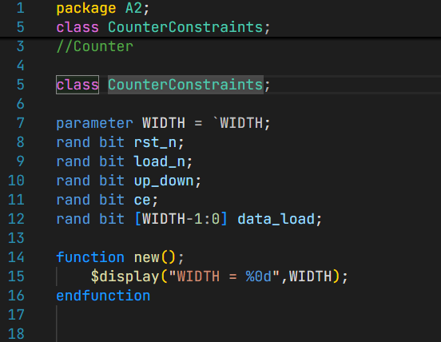

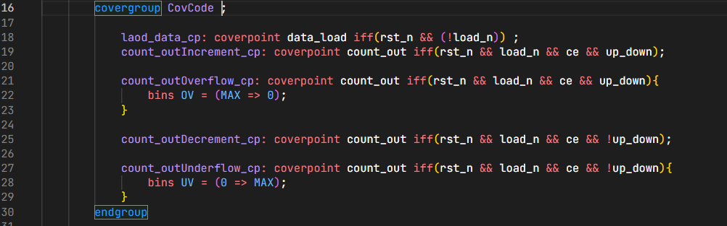

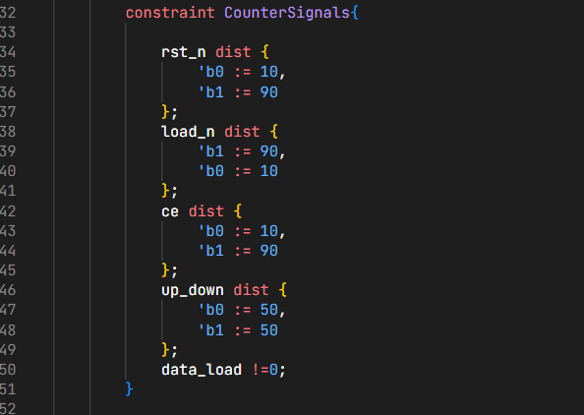

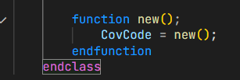

# SVA module:

# 

# 

# 

# Counter interface:

# Top module:

# Test bench:

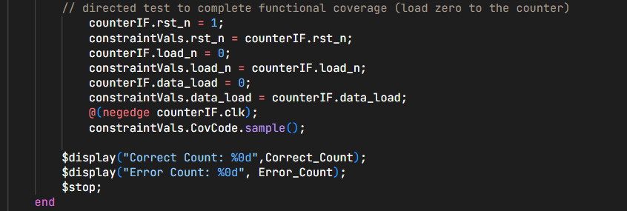

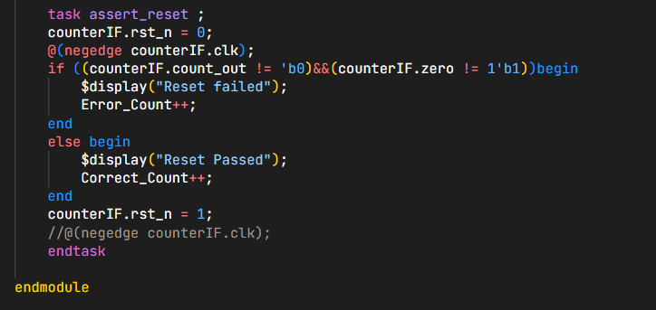

# Do file:

# 

# Result:

# 

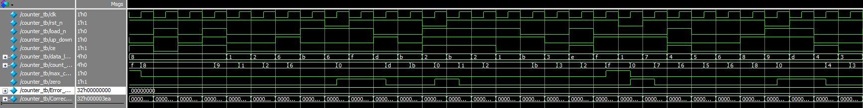Waveform:

# Functional Coverage:

# 

# Assertion coverage:

# 

# Code Coverage :

# 

# 

# Q4) Configuration Register:

# Verification Plan:

|  |  |  |  |  |
| --- | --- | --- | --- | --- |
| **Label** | **Design Requirement Description** | **Stimulus Generation** | **Functional Coverage** | **Functionality Check** |
| Config1 | Check reset functionality by asserting reset and compare each register value to its corresponding in reset_assoc[] array. | Directed at the start of the simulation | - | A checker in the testbench to ensure correct reset values for every register |
| config2 | For each register, write the inverted value for its default reset value, so that any unwritable bit is detected | Directed during the simulation | **-** | A checker in the testbench to ensure correct values for every register |

# TestBench:

# 

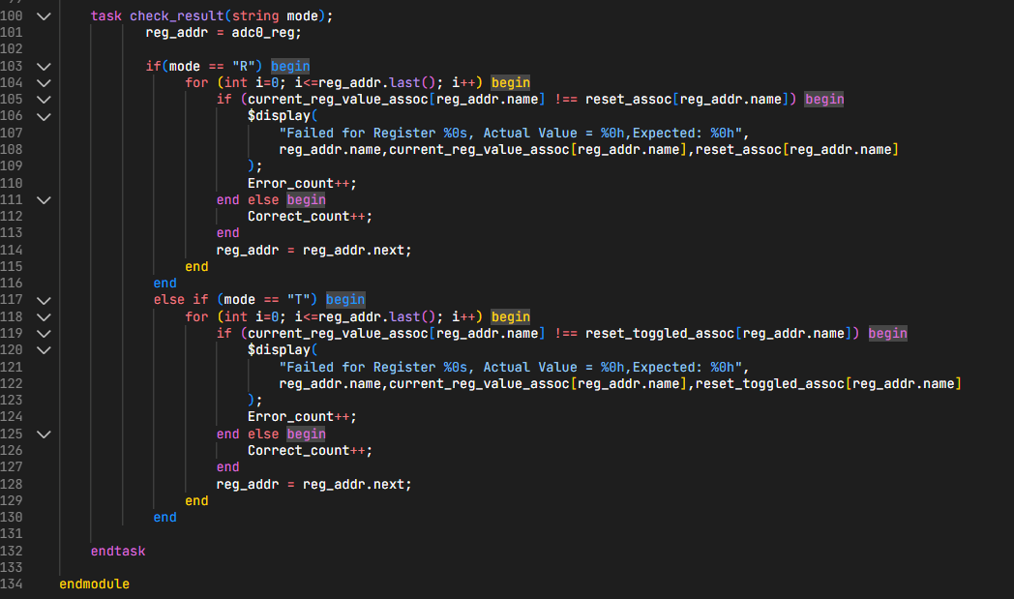

# Fixed Design:

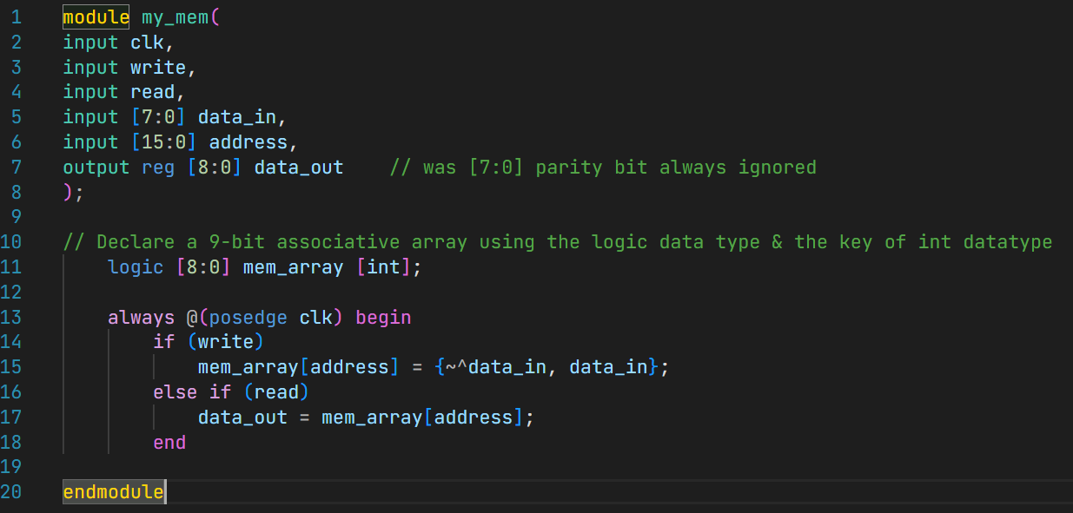

# Do file:

# Results:

# 

# Bug:

|  |  |  |  |
| --- | --- | --- | --- |
| **Resigter** | **Stimulus** | **Expected output** | **Actual output** |
| Adc0_reg | Toggled reset default value | ‘h0000 | ‘hFFFE |
| Adc1_reg | Toggled reset default value | ‘hFFFF | ‘hFEFF |
| Temp_sensor0_reg | Toggled reset default value | ‘hFFFF | ‘hFFFC |
| Temp_sensor0_reg | Toggled reset default value | ‘hFFFF | ‘hFFFE |
| analog_test | reset default value | ‘hABCD | ‘hABCC |
| digital_test | Toggled reset default value | ‘hFFFF | ‘hFFFE |
| amp_gain | Toggled reset default value | ‘hFFFF | ‘hFFFE |
| digital_config | Toggled reset default value | ‘hFFFE | ‘h7FFe |